Power and Conflict Poetry – Key Quotes
Ozymandias  “Two vast and trunkless legs of stone"  "sneer of cold command"  “The hand that mocked them and the heart that fed"  "king of kings"  "Look on my works, ye Mighty, and despair!"  "colossal wreck, boundless and bare" | 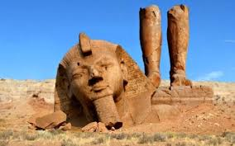
London  "I wander through each chartered street, Near where the chartered Thames does flow"  "Marks of weakness, marks of woe."  "In every cry of every man"  "The mind-forged manacles"  "Every black'ning church appalls"  "plagues the marriage hearse" | 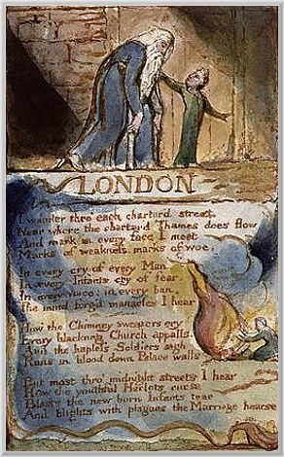
Extract from, The Prelude  "(led by her)"  "It was an act of stealth and troubled pleasure"  "like one who rows, proud of his skill, to reach a certain point with an unswerving line"  "my boat went heaving through the water like a swan"  "When, from behind that craggy steep till then the horizon's bound"  "a huge peak, black and huge"  "no pleasant images of trees, of sea or sky, no colours of green fields"  "were a trouble to my dreams" | 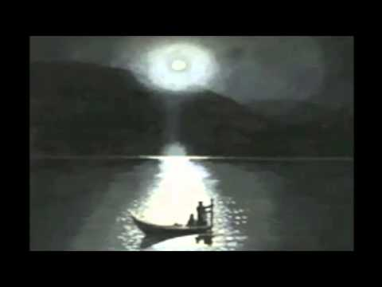
My Last Duchess

"my last duchess”
"Sir, twas not her husband's presence only, called that spot of joy into the Duchess' cheek"
"My gift of a nine-hundred-years-old name"
“she smiled, no doubt, whene'er I passed her, but who passed without much the same smile?"
"I gave commands; Then all smiles stopped together”
Notice Neptune…/Taming a sea-horse”

The Charge of the Light Brigade  "Into the valley of Death Rode the six hundred."  "theirs not to make reply/ theirs not to reason why/ theirs to do and die"  "They that had fought so well /Came thro' the jaws of Death /Back from the mouth of Hell"  “someone had blundered”  "Honour the charge they made! Honour the Light Brigade" | 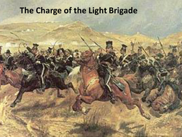
Exposure  "Our brains ache, in the merciless iced east winds that knive us..."  "brambles...rumbles"  "The poignant misery of dawn"  "Dawn massing in the east her melancholy army"  "Sudden successive flights of bullets streak the silence."  "We cringe in holes, back on forgotten dreams"  "Slowly our ghosts drag home" | 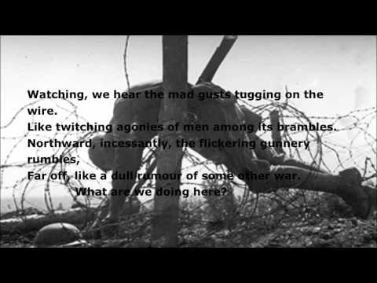
Storm on the Island  "We are prepared: we build our houses squat"  "there are no stacks or stooks that can be lost."  "Forgetting that it pummels your house too."  "Exploding comfortably down the cliffs"  "spits like a tame cat turned savage"  "wind dives and strafes invisibly...We are bombarded by the empty air."  "Strange, it is a huge nothing that we fear." | 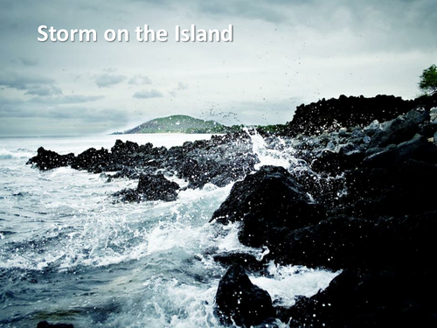
Bayonet Charge  “bullets smacking the belly out of the air-“  “he lugged a rifle numb ass a smashed arm”  “patriotic tear”  “A yellow hare that rolled like a flame/ And crawled into a threshing circle”  'King, honour, human dignity, etcetera” | 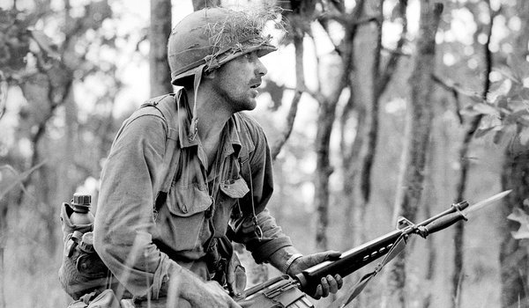
Remains  "one of them legs it up the road"  "probably armed, possibly not"  "Well myself and somebody else and somebody else are all of the same mind"  "it rips through his life - I see broad daylight on the other side."  "and he's there on the ground, sort of inside out"  "End of story, except not really."  "And the drink and drugs won't flush him out-"  "he's here in my head when I close my eyes, dug in behind enemy lines"  “his bloody life in my bloody hands” | 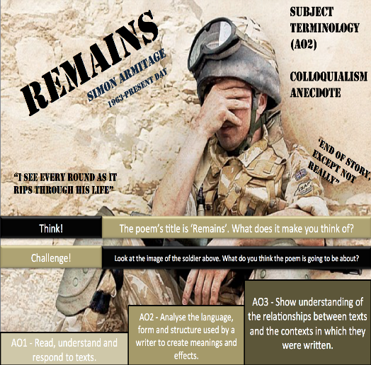
Poppies  "...placed on individual war graves. Before you left..."  "spasms of paper red, disrupting a blockade"  "all my words flattened, rolled, turned into felt"  "I was brave, as I walked with you, to the front door"  "leaned against it like a wishbone"  "I listened, hoping to hear your playground voice catching in the wind." | 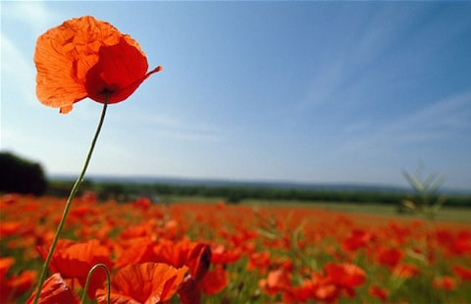
War Photographer  "set out in ordered rows"  "as though this were a church and he a priest preparing to intone a mass."  "All flesh is grass."  "beneath his hands, which did not tremble then though seem to now.  "A hundred agonies in black-and-white from which his editor will pick out five or six"  "and they do not care." | 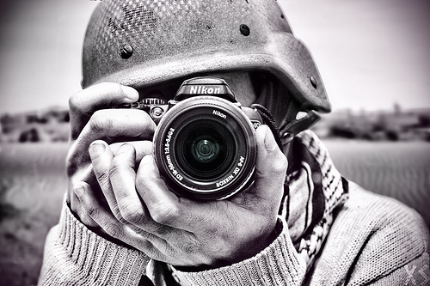
Tissue

"Paper that lets the light shine through"
"where a hand has written in the names and histories"
"this/ is what could alter things."
"might fly our lives like paper kites"
"how easily they fall away on a sigh,' 'turned into your skin"

The Emigree  "but my memory of it is sunlight-clear"  "It may be at war, it may be sick with tyrants"  "but I am branded by an impression of sunlight."  "the frontiers rise between us, close like waves"  "opens and spills a grammar"  "I comb its hair and love its shining eyes."  "They accuse me of being dark in their free city." | 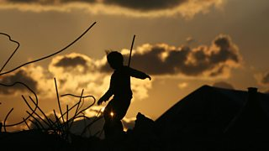
Checking Out Me History  "Dem tell me"  "Bandage up me eye with me own history"  "Toussaint de beacon of de Haitian Revolution"  "fire-woman struggle hopeful stream to freedom river"  "a healing star among the wounded a yellow sunrise to the dying"  "But now I checking out me own history I carving out me identity" | 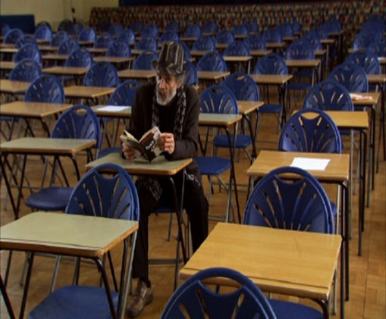
Kamikaze  "Her father embarked at sunrise with a flask of water, a samurai sword"  "enough fuel for a one-way journey into history"  "the loose silver of whitebait and once a tuna, the dark prince, muscular, dangerous”  "they treated him as though he no longer existed"  "till gradually we too learned... that this was no longer the father we loved."  "And sometimes, she said, he must have wondered which had been the better way to die." | 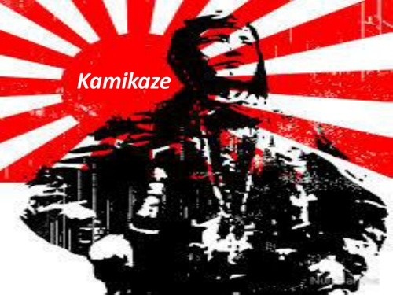

Get someone to test you on the key quotes. Once you have learnt them, for each poem, learn four key ideas that you can explore in depth. Again having an image for each idea will help you to remember them.

